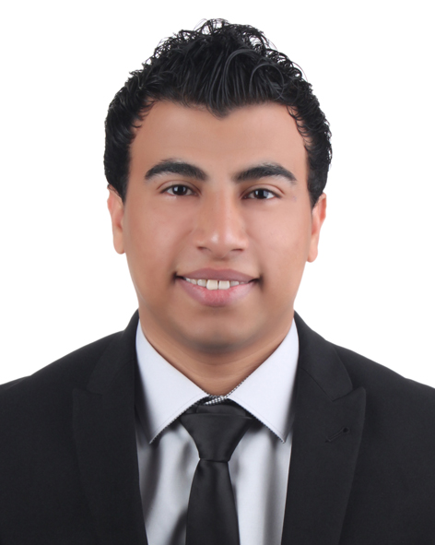

Ahmad Hassan Mohamed, MBA
Dubai, United Arab Emirates
Mobile: 00971552216814
Email: ahmed_ha2046@yahoo.com

Career Objective:

To obtain an accounting position where I will be able to contribute my skill, knowledge and experience to a company that will give me an opportunity to develop my career.
Skill Summary:

- Enthusiastic Finance personnel having 4 years of experience.
- Working experience of SAP and advanced knowledge of Windows XP & MS Excel.
- Excellent Interpersonal and communication Skills.
- Result oriented and Meets deadlines.
- Team building, Bookkeeping, Computer and Reporting skills.
- Proficient in data entry and management.

IT’S Proficiency:

- SAP (System Application and Program)
- Microsoft Dynamics GP
- MS Office (Advanced Excel & Word)

Languages:

- Arabic
- English

Academic:

Northampton UK University, UK
Going to start at Jan 2016
MBA in Finance & Accounting (MBA in Progress)

Cairo University, Egypt
Concentration: Financial Accounting

May 2011 Bachelor's Degree in Finance & Accounting

Education:

Sept 2011 International Group for Accounting & Auditing & American Institute
QA Diploma
Concentration: Finance & Accounting

Sept 2011 International Group for Accounting & Auditing & American Institute
Certificate of Successfully Completing
English Computerized Accounting by Using Advanced Excel

Professional Experience:

COMPANY | DESIGNATION | FROM | TO
Intigral (Saudi Telecom Company), DUBAI | Accounts Payable Accountant | 06 / 04 / 2014 | Present

Established in 2009 as a joint venture between Saudi Telecom Company (STC) 71% and All Overseas Ltd (ASTRO) (29%). Intigral is an end-to-end solution provider focused on delivering digital media content services to regional telecommunication operators. We offer a one-stop shop for the region's operators, easing their transition into the digital media space and aiming the enhancement of digital experience of consumers irrespective of their access channels, be it mobile, IPTV or web through focusing on integration, information and intelligence. Being the largest digital company in MENA, sourcing, creating and delivering digital content.
Responsibilities:

- Review all invoices for appropriate documentation and approval prior to payment.
- Match invoices to checks, obtain all signatures for checks and distribute checks accordingly.
- Respond to all vendor inquiries.
- Booking entries of Vendors Invoices.
- Processing Payments of Vendors.
- Purchase Order (PO) and creditor Reconciliation.
- Booking entries for others expenses claim & Travel Expenses and Utility bills.
- Audit and process credit card bills.
- Managing Petty Cash expenses.
- Reconcile Supplier accounts to maintain accurate AP Ledger, GL Reconciliations with bank statement on monthly basis (Bank Reconciliations)
- Assist in month end closing.
- Preparing AP Report & Expense Report and Marketing Cost Report.
- Assisting and reporting directly to Accounting Manager.

COMPANY | DESIGNATION | FROM | TO
BRF Middle East, Dubai | Trade Claim Accountant | 14 / 02 / 2012 | 25 / 03/ 2014

BRF is a global leader in the Food industry, one of the largest companies in this sector worldwide, owner of a variety of products and brands. BRF is one of the largest employers in Brazil, with over 100,000 employees in Brazil and abroad.

.Responsibilities:

- Accounts Receivable & Trade Marketing

- Responsible for all GL entries pertaining to Sales and Marketing expenses.
- Responsible for maintaining company’s Sales and Marketing budget and producing quarter/annual reports to top management.
- Preparing, and sustaining provision for S&M Expense accounts.
- Participating in the finalization of the company’s receivables from Vendors in coordination with the accounts payable department.
- Coordinate with Sales-teams, Brand Managers, Product Executives and other members of the team, and across the business.
- Coordinate with inventory department to record promotional expenses shared by Principals in order to raise promotion debit notes.
- Preparing reconciliations of sales & marketing expense accounts and providing marketing expenses monthly report for financial closing.
- Preparing management reports (Marketing Expenses – Accrued Expenses – A/R from Vendor).
- Reporting directly to the Finance Manager & Marketing Director.

COMPANY | DESIGNATION | FROM | TO
Etisalat, Egypt | Accountant | Dec 2010 | Dec 2011

Etisalat is a multinational, blue-chip organization with operations in 19 countries across the Middle East, Africa and Asia. An estimated 2 million people benefit from regular work supplying Etisalat or its customers, including more than 40,000 employees who are directly employed by the company.

Responsibilities:

- Maintenance of the general ledger.
- Monitor journal entry preparation and reconciliation of monthly accounts.
- Petty cash management
- Reconcile financial discrepancies.
- Managing Accounts Payable & Receivable.

Personal Details:

Date of birth: June 1989
Visa Status: Free Zone Visa
Civil Status: Single
Nationality: Egyptian

